**Spanish police investigate 1. ......... of four migrants forced off speedboat**

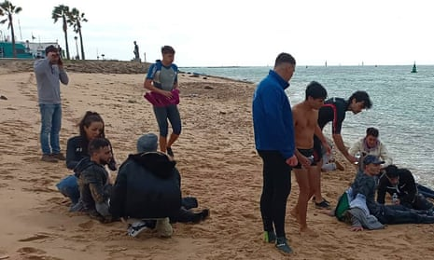

Spanish 2. ................ have opened an inquiry after four people were killed as a 3. ............... of being forced out of a moving speedboat 4. .......... the sea just metres 5. ....... the southern shores of Andalucía.

The people who died 6............ Wednesday were among 27 passengers apparently forced 7. .........the fast-moving vessel by its drivers near Camposoto beach in the province of Cádiz, officials 8. ....... Another eight were left near Sancti Petri beach. All 35 9......... were believed to be migrants from northern [Africa](https://www.theguardian.com/world/africa), the Spanish government press office said.

The 10. ...... of the passengers forced off the boat, including six children, survived. Four people were taken to 11. ......., some with hypothermia.

Images on social 12. .......... appeared to show a black vessel near a beach as people were being pushed off the side of the 13. ............. A handful of others were already in the cold, choppy waters, struggling to stay afloat.

The incident comes months after an internal report by Frontex, the EU border and coast guard agency, said smugglers 14. .......... increasingly using speedboats 15. ...... transport migrants from [Morocco](https://www.theguardian.com/world/morocco) to Spain.

Often when they neared the shores 16. ....... Europe, the drivers used violence to hurriedly throw or force 17. ............. off the boats, turning back quickly to avoid being intercepted by police, the [newspaper El País reported](https://elpais.com/espana/2023-11-29/mueren-cuatro-inmigrantes-en-cadiz-tras-ser-arrojados-al-mar-desde-una-narcolancha.html).

Javier González, who manages a company offering windsurfing lessons, told reporters: “We saw a drug trafficking boat arriving but they weren’t trafficking 18. ............... but migrants. Suddenly, they began jumping and some were thrown.”

González and his son rescued eight people, he said. “One of them told 19. ....... that they put a gun to him and told him that either he jumped 20. ............ they would shoot him.” González and his 21. ........... made two trips to pull people from the water.

“They were all young, between 15 and 20 years old. Those who were able to talk thanked us,” he said. “You can’t 22. ................. their faces, they were terrified. They said they had paid €5,000 (£4,300) for this trip.”

KEY:

deaths, police, result, into, from, on, off, said, people, rest, hospital, media, boat, were, to, of, migrants, drugs, us, or, son, imagine